|  |  |
| --- | --- |
|  |  |

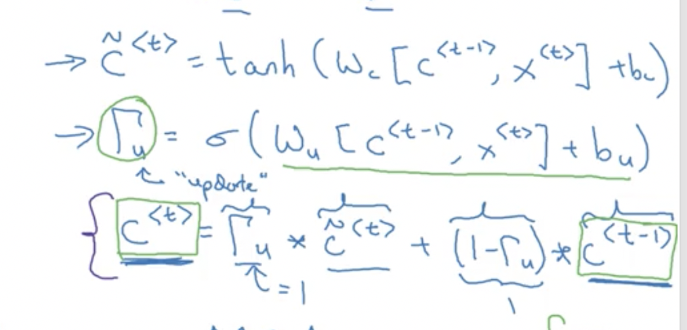

|  |  |  |  |  |  |  |  |  |  |  |  |  |  |  |  |  |  |  |  |  |  |  |  |  |  |  |  |  |  |  |  |  |  |
| --- | --- | --- | --- | --- | --- | --- | --- | --- | --- | --- | --- | --- | --- | --- | --- | --- | --- | --- | --- | --- | --- | --- | --- | --- | --- | --- | --- | --- | --- | --- | --- | --- | --- |
| |  |  |  |  | | --- | --- | --- | --- | | wxh | | | | | 0.287027 | 0.84606 | 0.572392 | 0.486813 | | 0.902874 | 0.871522 | 0.691079 | 0.18998 | | 0.537524 | 0.09224 | 0.558159 | 0.491528 |  |  |  |  |  | | --- | --- | --- | --- | | whh | | | bias | | 0.427043 | 0.17 | 0.23 | 0.567001 | | 0.33 | 0.12 | 0.4 |  | | 0.8 | 0.66 | 0.9 |  | |  |
|  |  |

Output:

input: H

1. Next character
2. Next memory cell

c0 = (0; 0; 0)

x1 = (1; 0; 0; 0)

c_tilda1 = tanh(w_c_xh*x1 + w_c_hh*c0 + bias_c)

= (0,6931679369; 0,8995536059; 0,8021185304)

r_u = sigmoid(w_r_xh*x1 + w_r_hh*c0 + bias_u)

= (0,6130141761; 0,5938731029; 0,5547792351)

c1 = Hadamard product(r_u, c_tilda1) + Hadamard product(1-r_u, c0)

= (0,4249217718; 0,5342206912; 0,4449987048)

y_hat1 = softmax(c1)

= (0,6046603847; 0,630466982; 0,6094494753)